Reasons to Develop Communication Skills

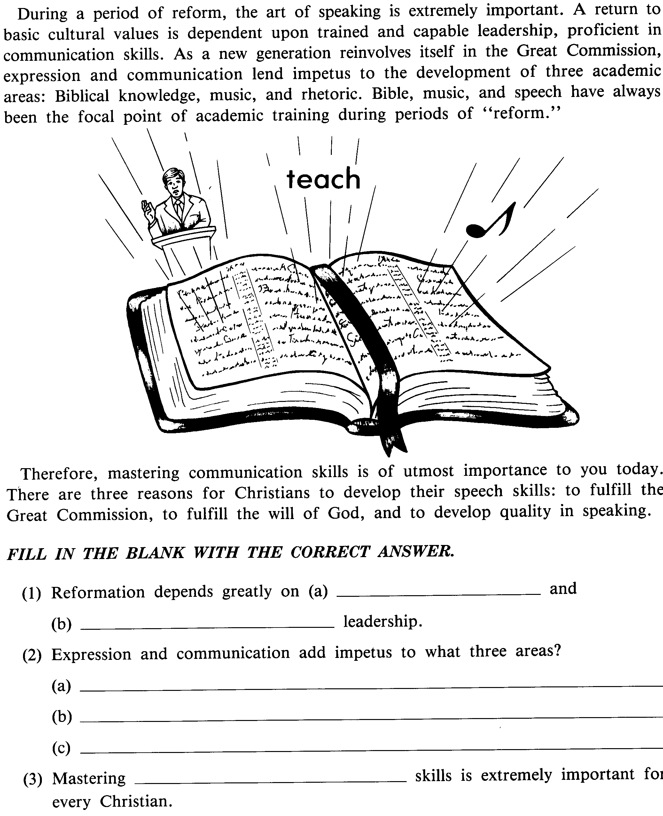
trained
capable
Biblical knowledge
Music
Rhetoric
communication

